SECTION5-VAGRANT

1.Vagrant IP.RAM.CPU

Ls -a:

🡪.vagrant file :where vagrant keeps all its information

Ls ~/.vagrant.d/:global vagrant file which is hidden

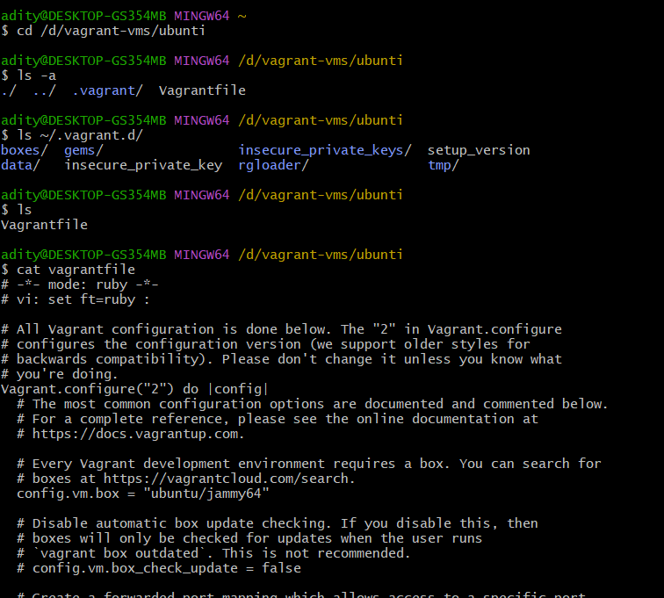

🡪open the vagrant file in the specified dir and make the changes and uncomment some lines

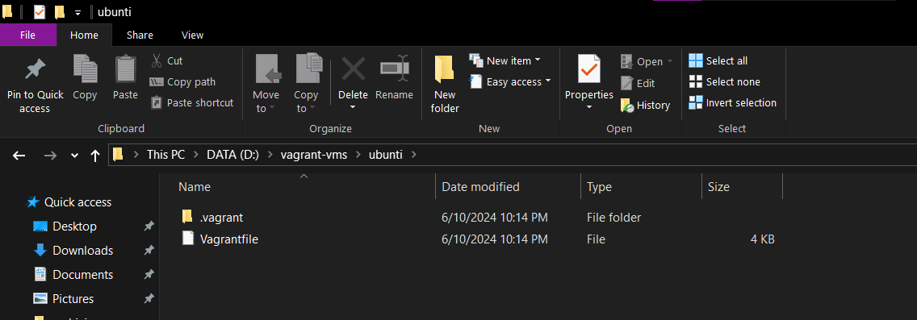

🡪make the changes

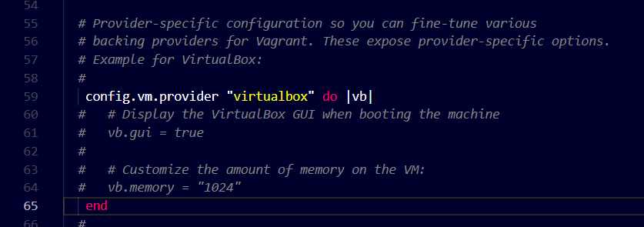

-increasing the ram

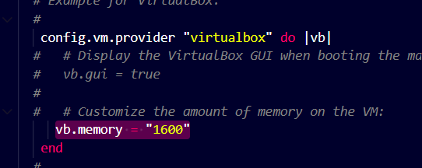

-for bridge settings uncomment

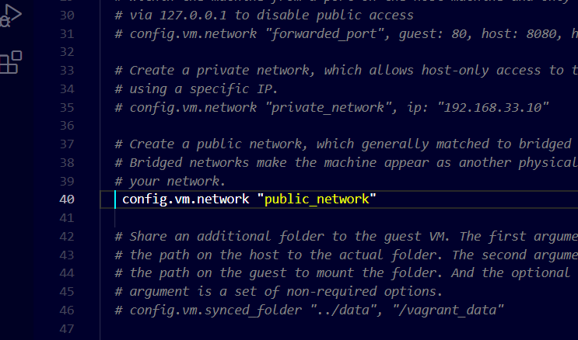

-uncomment to have a static IP address

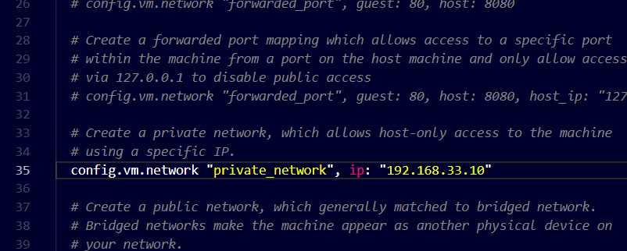

-change the IP octat from 33 to 56 becz other computers block numbers allow range from 50-60 and 56 is ideal

-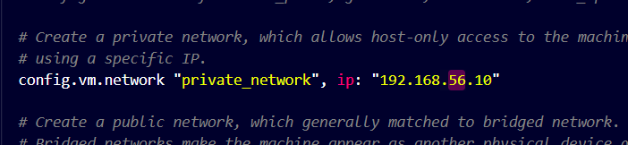

-cahnge 1 to 2 to add more CPUs

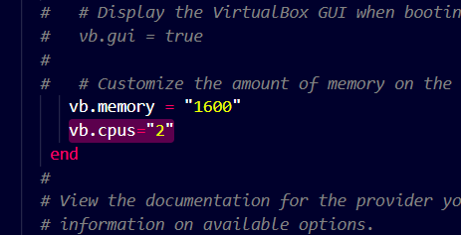

Validate the changes using cat command

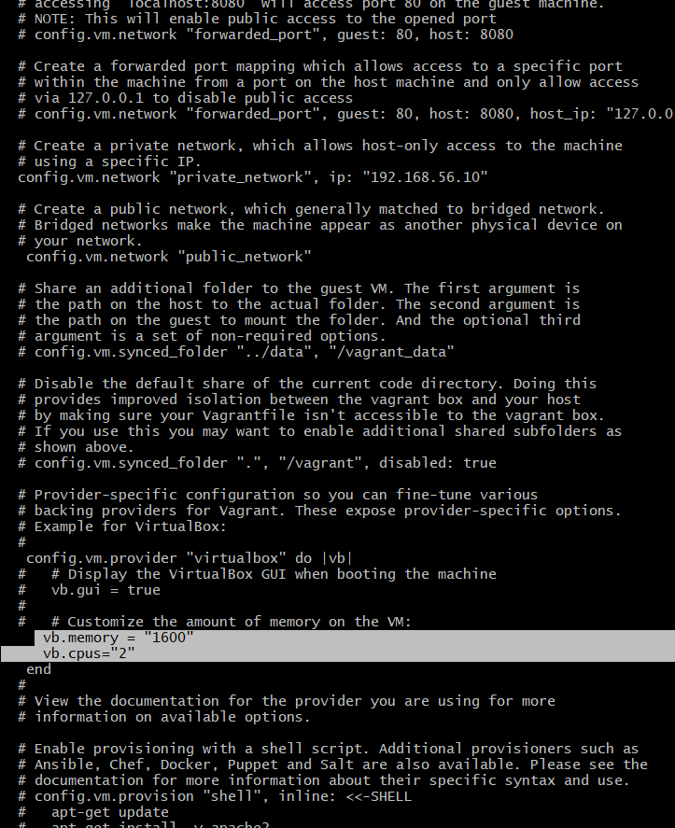

-reload the vagrant to see all the settings u have implimented

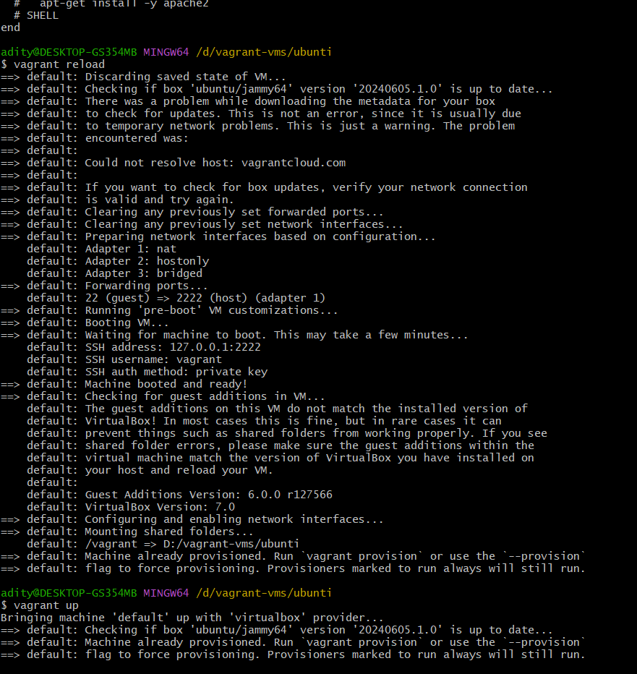

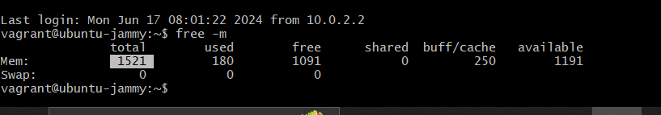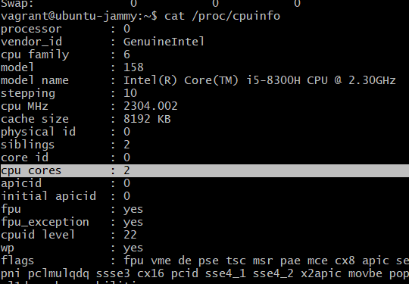

2.vagrant sync directories

/vagrant:is the guest path

D:/vagrant vms/ubunti is the host path

Any changes made in this path will affect both the huest as well as the host user

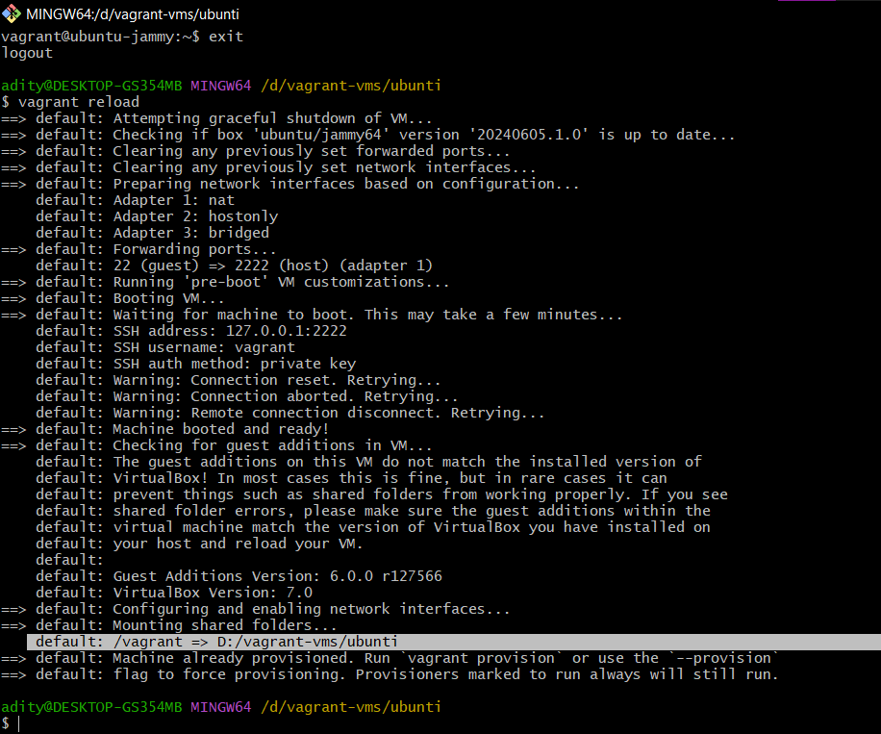

-create a new file in windows

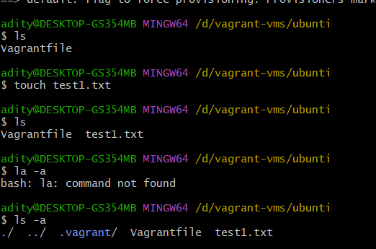

-u can see the corresponding file in the same directory in the pc

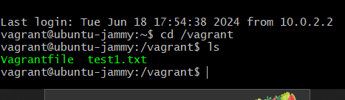

-the sync between the host machine in the left and guest mschine on right

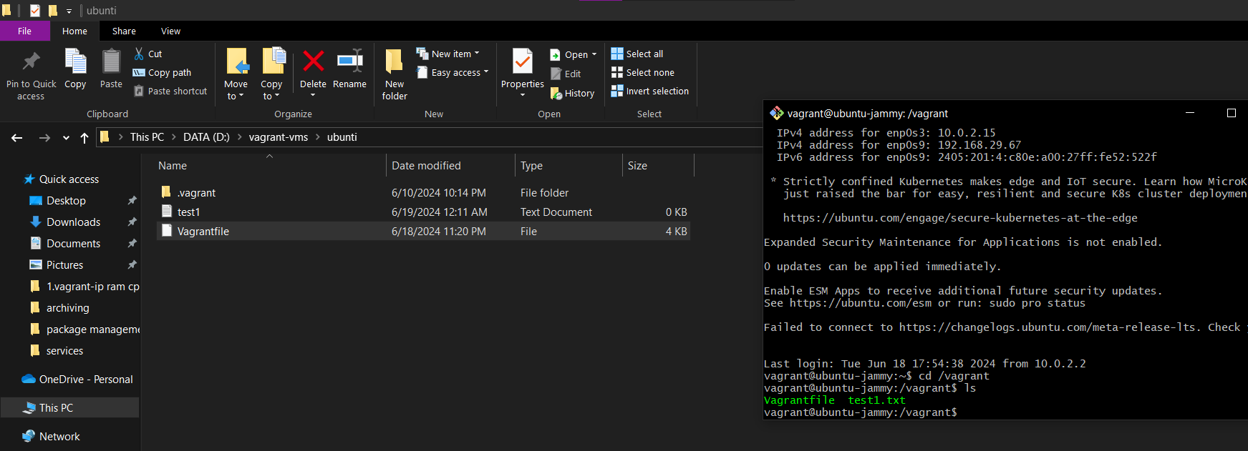

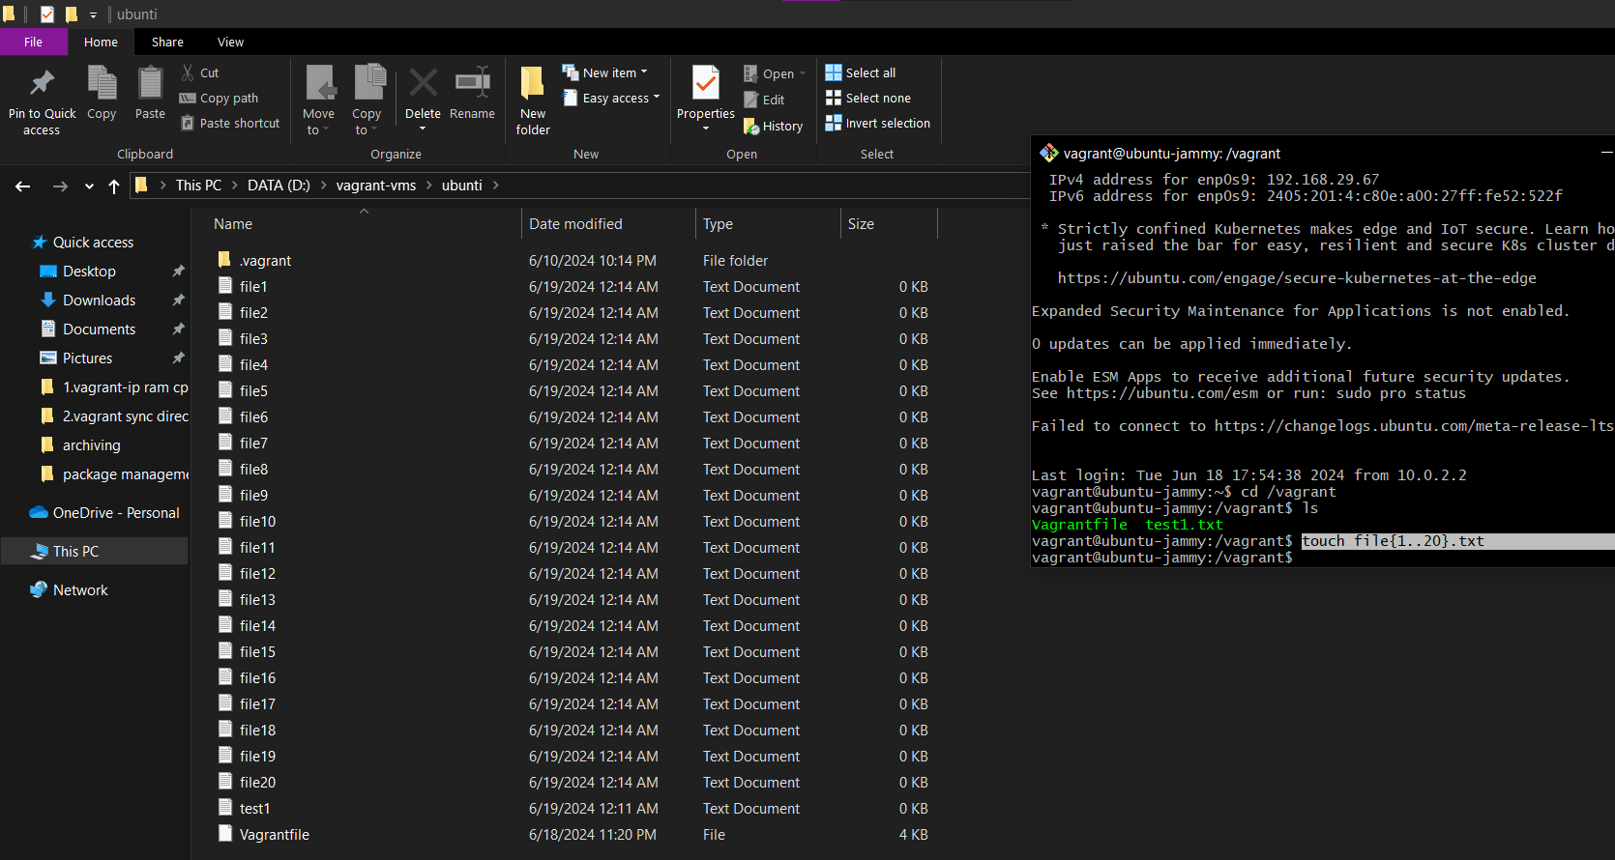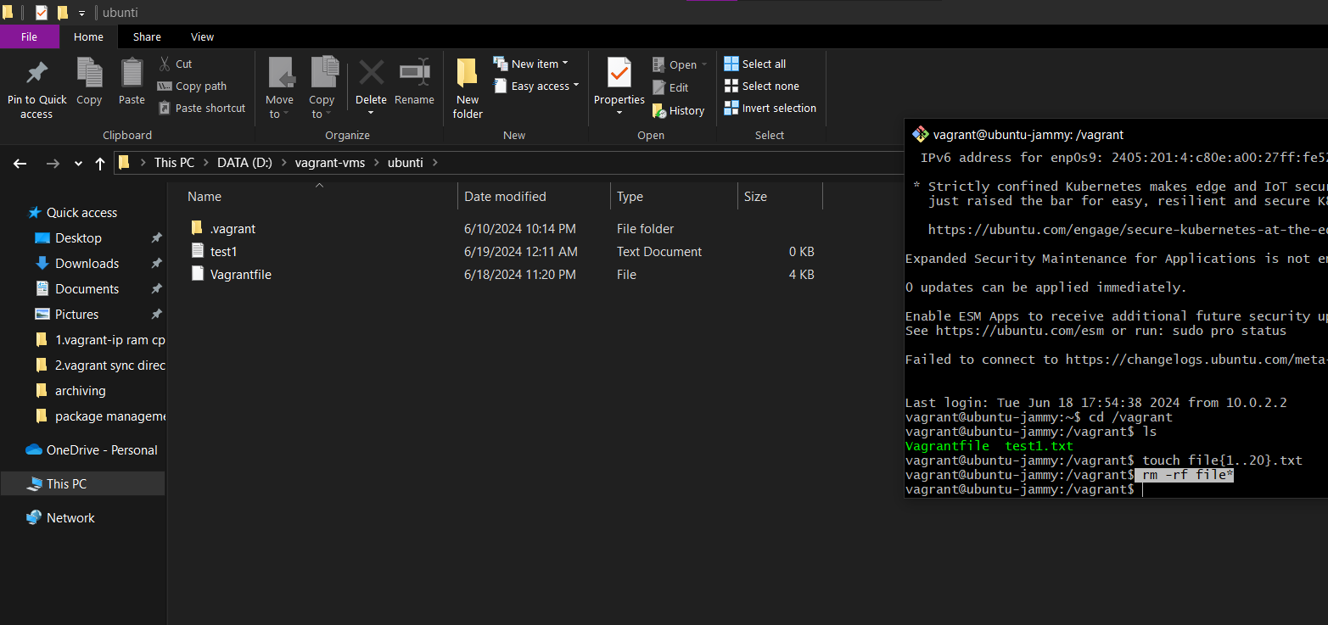

-we can also mention our won file path and create a new sync directory

-uncomment the following line

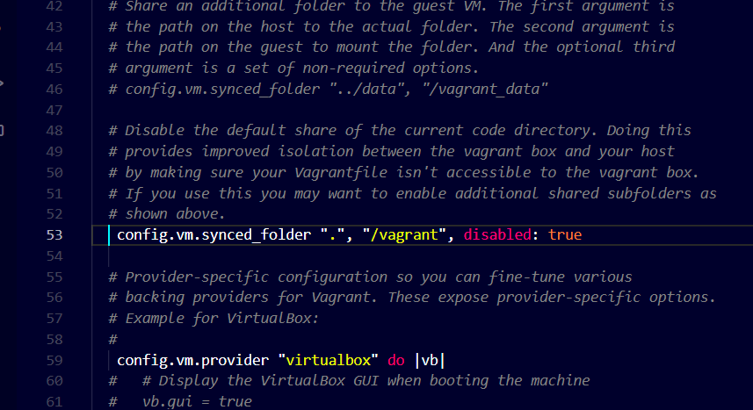

-give any name here

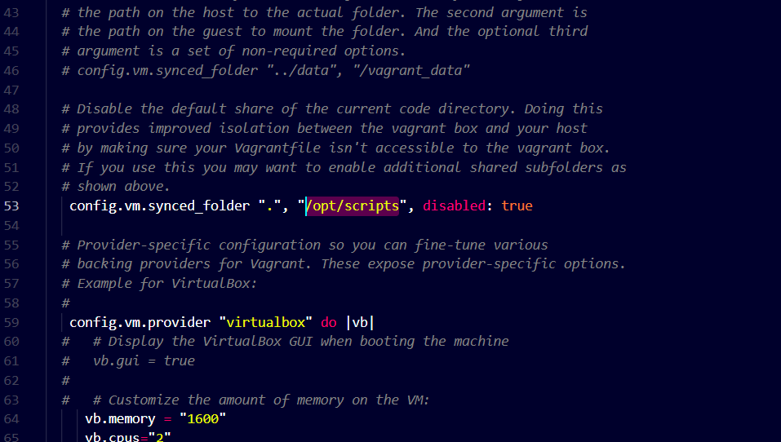

-create a new folder with name scripts and inside create another folder shellscripts

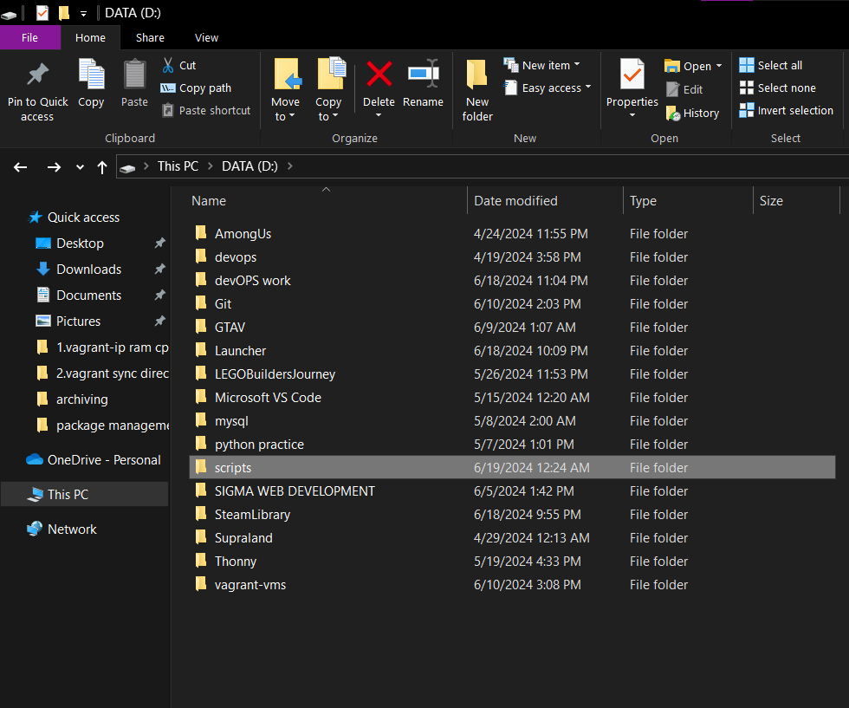

-now give a perfect directory name

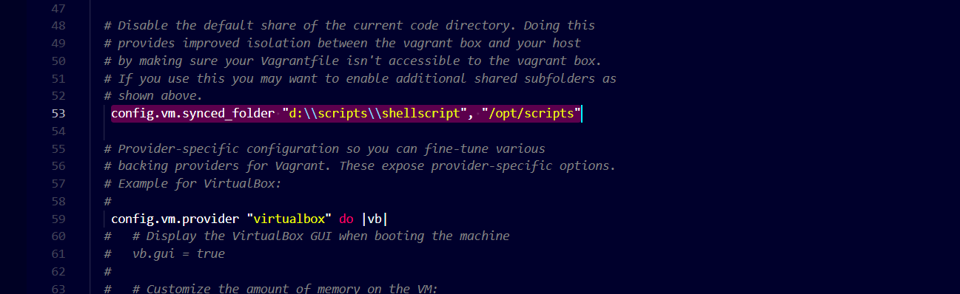

-here u can se another sync directory is added

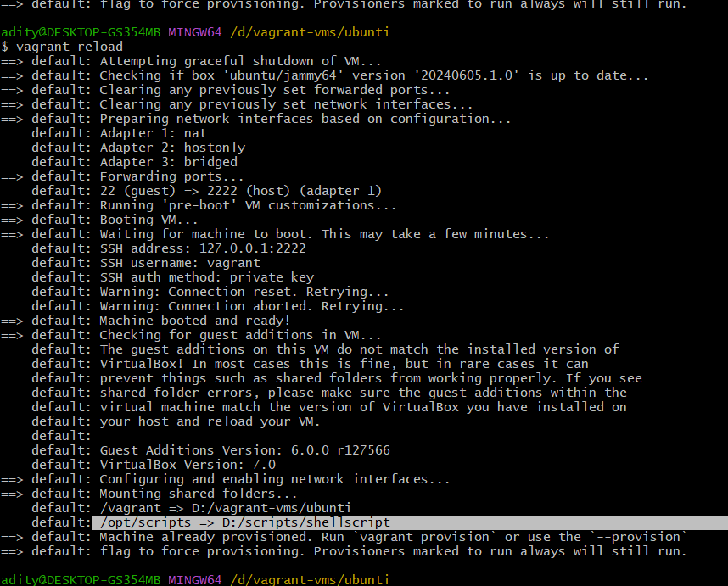

3.provisioning

open centos vagrant file

Make the following changes to adapt bridge and change the ipaddress from 33.10-to 56.16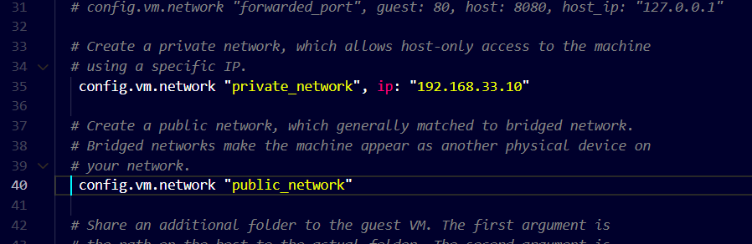

-change ip

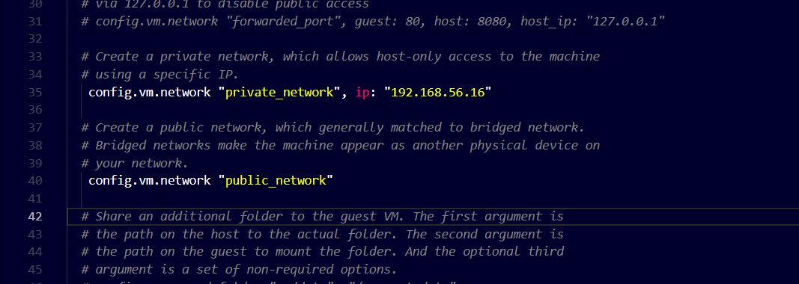

-uncomment the last 4 lines of the fire for provisioning

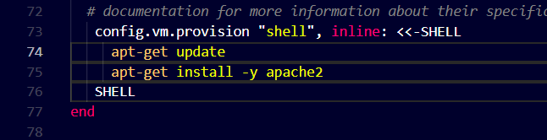

* Mentions the commands u want to get executed in provisionning

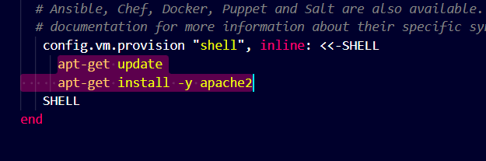

-add these commands u can add any command u need

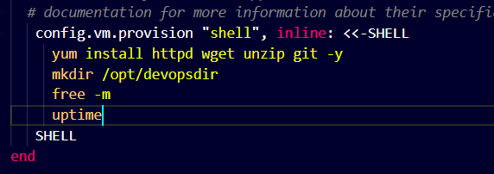

-in gitbash delete and reinstall the centos vagrantvm

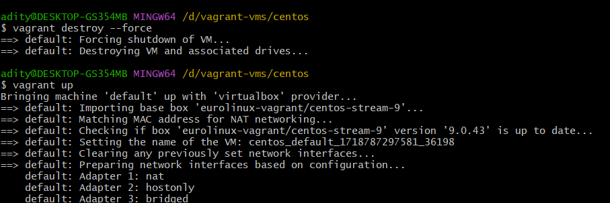

-these r the commands that we execute

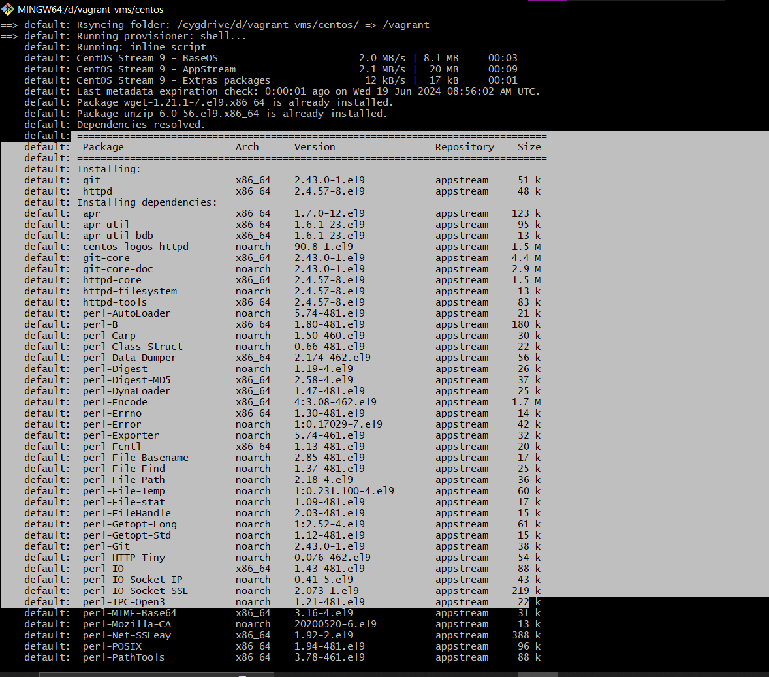

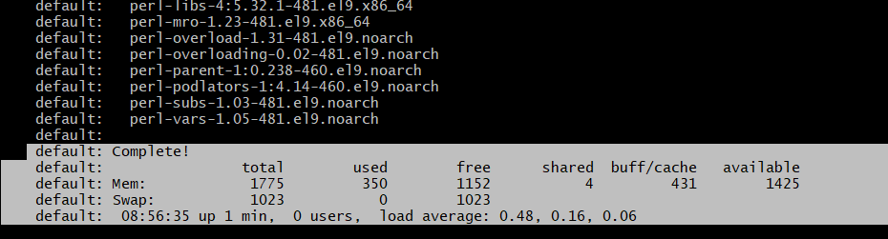

Provisioning will not work for vagrant reload command

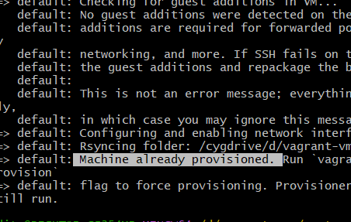

-for provisioning in the ubuntu file make the same changes

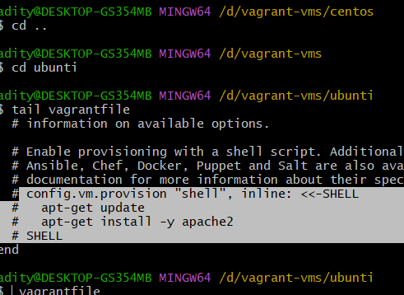

-uncomment

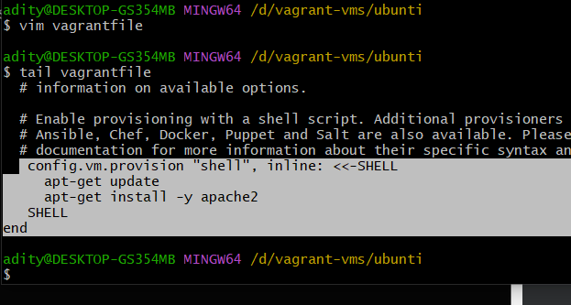

To force provisioning in the reload command in ubuntu use the following command

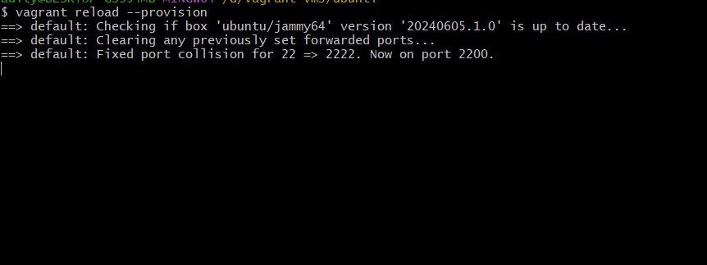

-open the vagrant file and copy the ipaddress

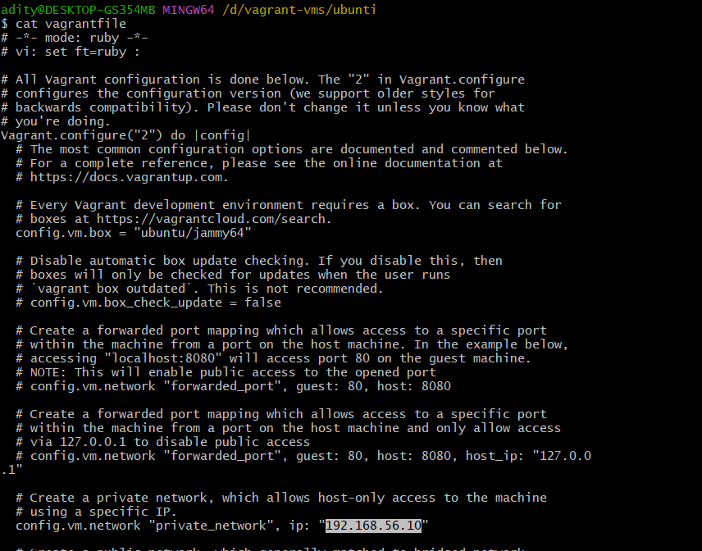

-usko browser pe dalo

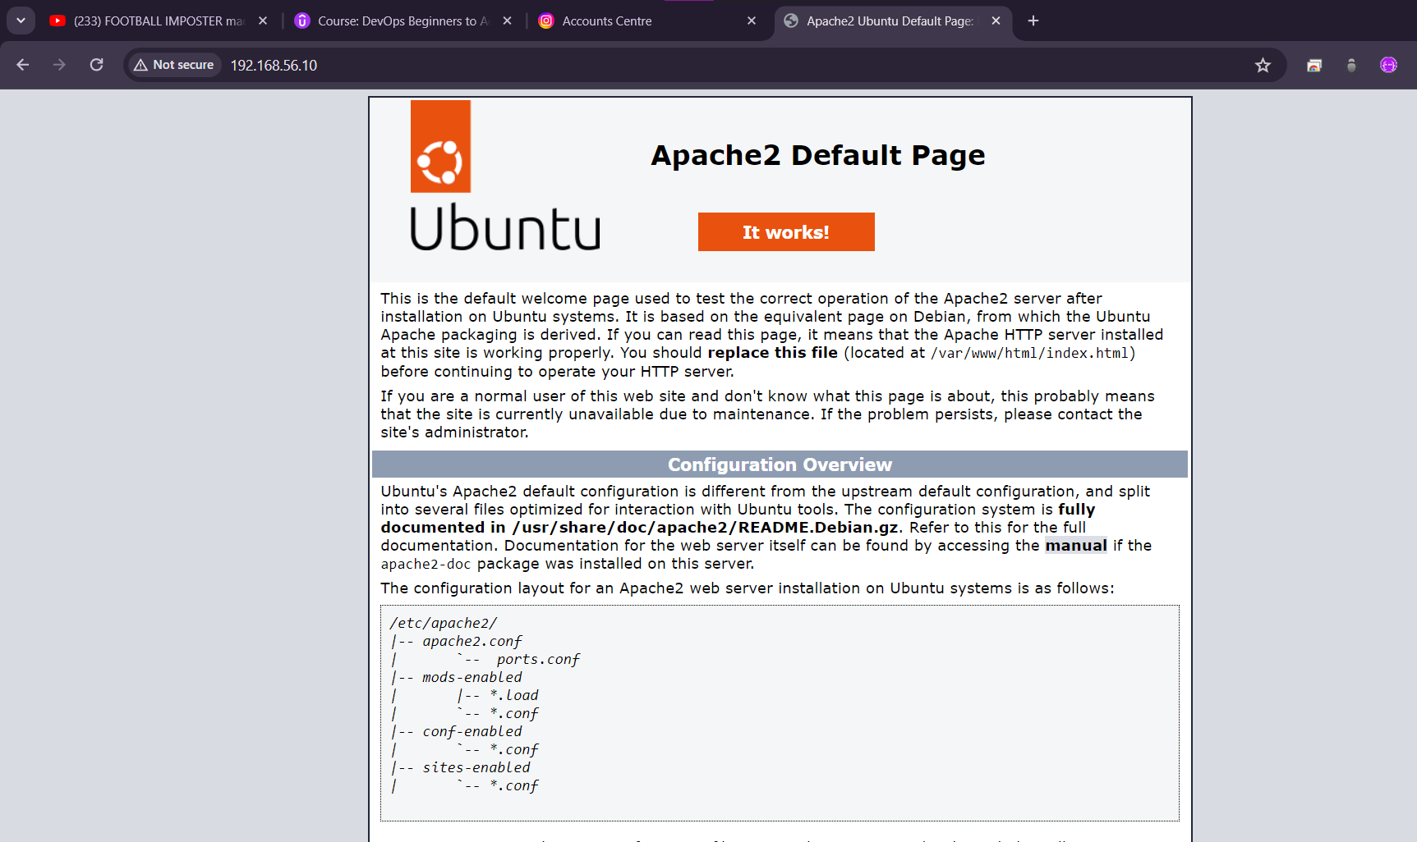

-destroy bothe the vms at the end

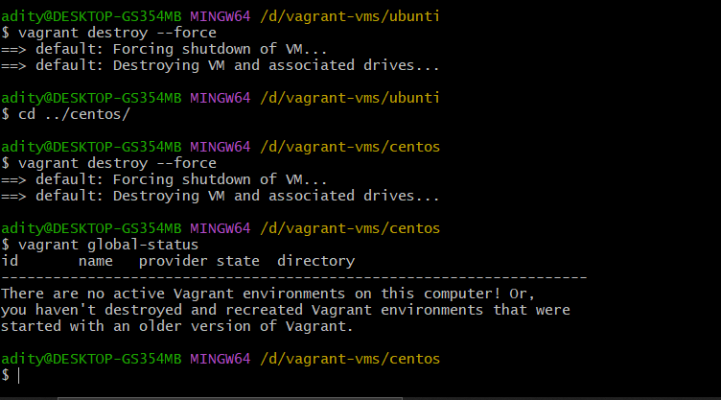

4.website setup

-Go to this website to select the template for your website

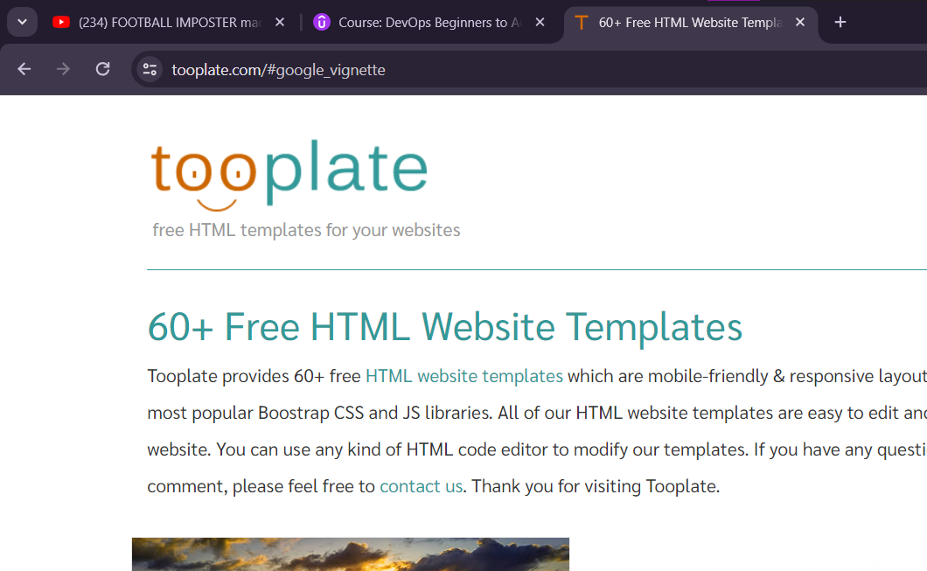

-I have chosen this template

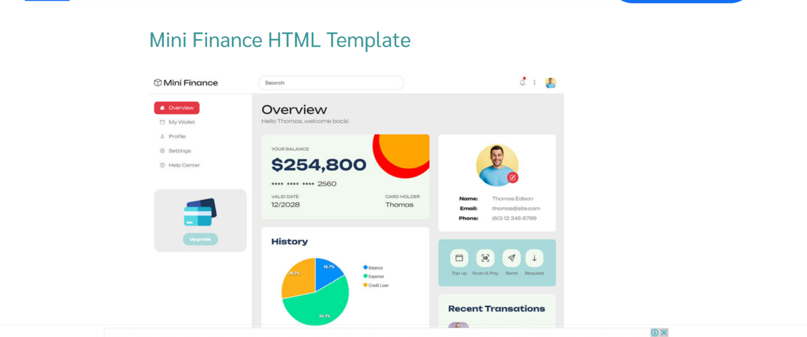

-create a new directory finance and powerup the vagrant

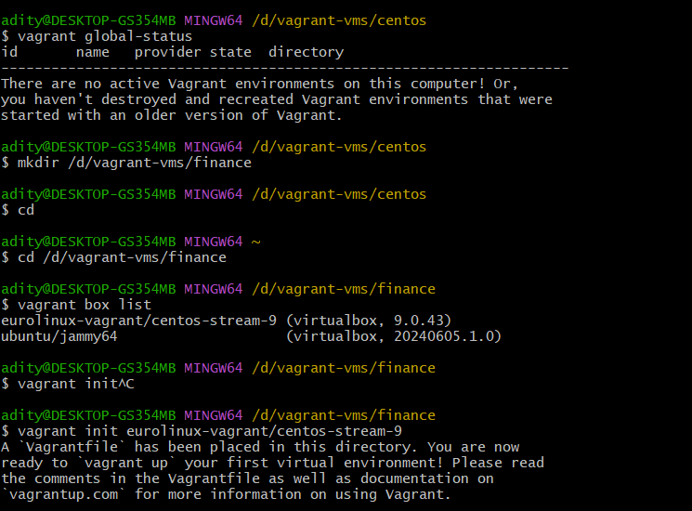

-uncomment the lines in vagrantfile

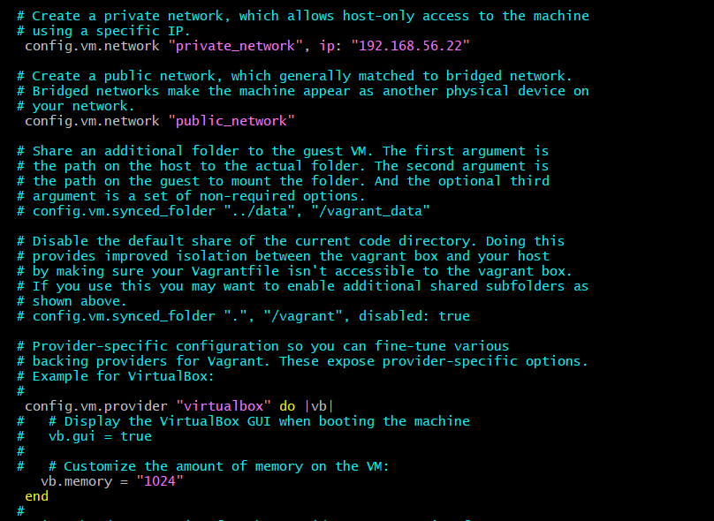

-changing the hostname to finance

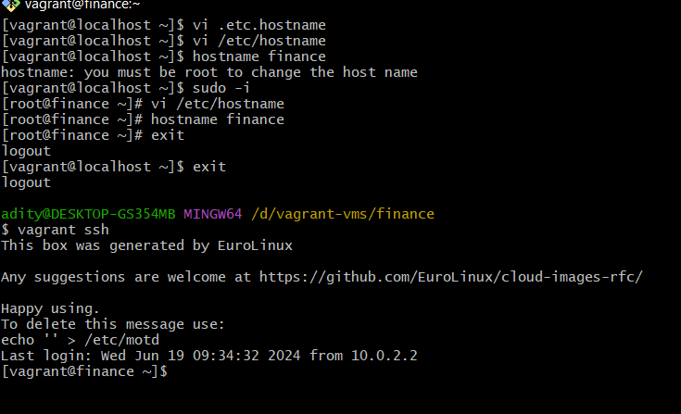

-install the following

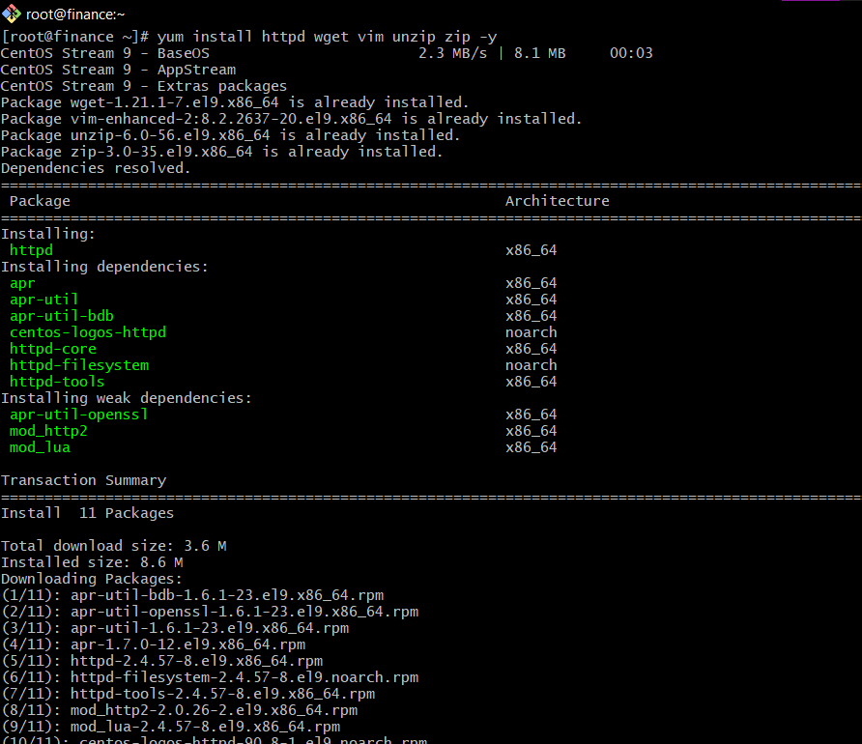

-start and enable the httpd service

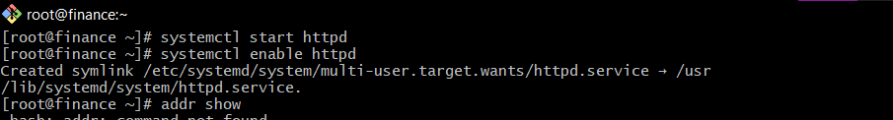

-find the ip address

-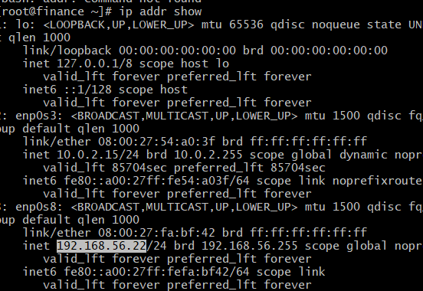

-paste the ip on browser to get the preview of our page

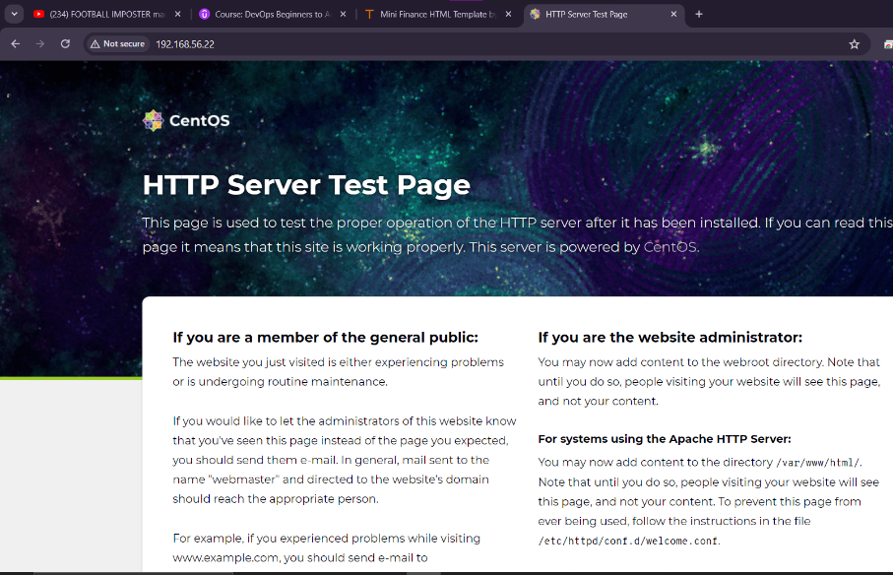

Read the lines of the file carefully

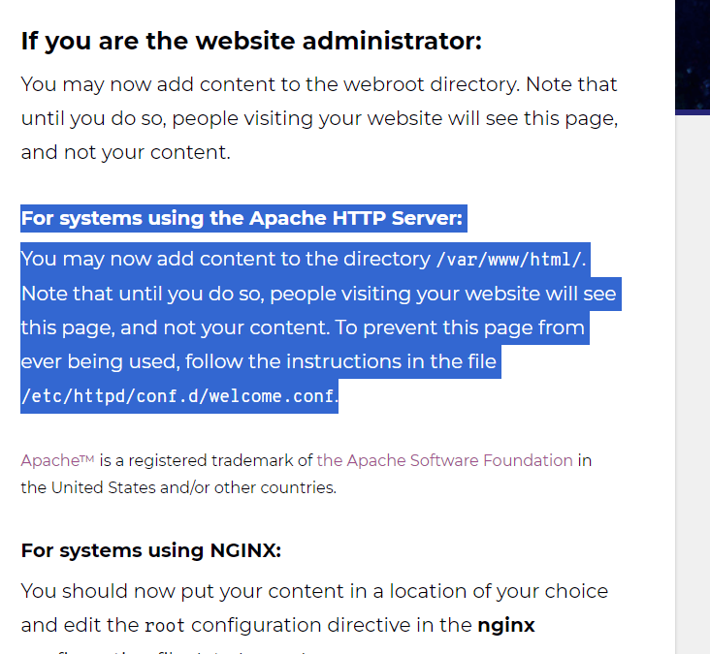

-add the content to the html file

-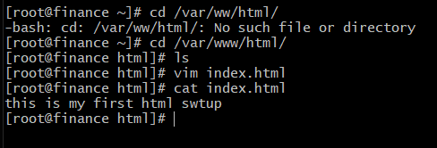

-make sure to restart he service whenever u make changes to the html or other content files



-page update

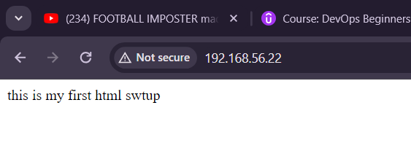

Download the template

F12🡪networking tab🡪click on the download button🡪zipfile🡪required drc copy

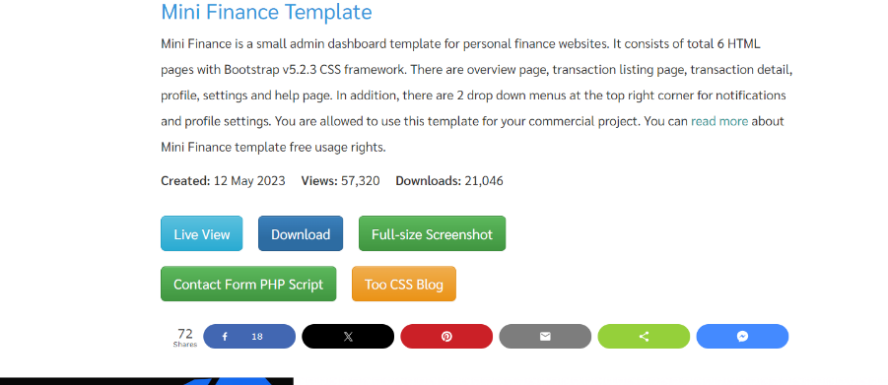

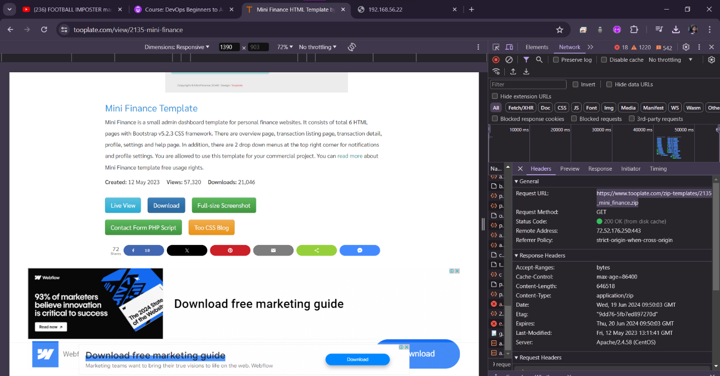

-now download the link and unzip it using wget

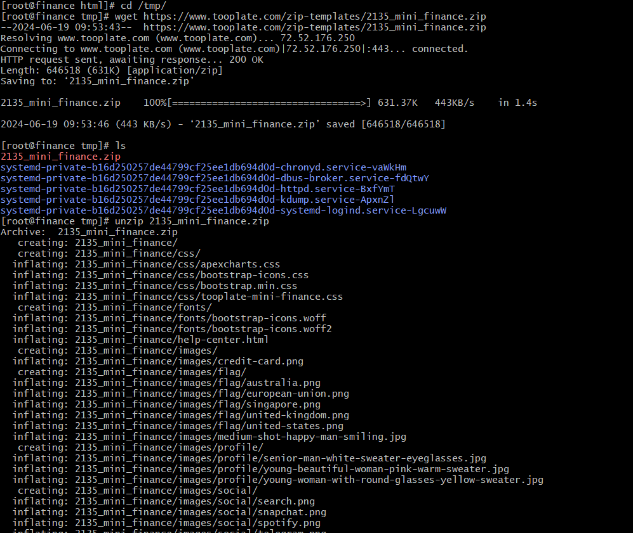

-copying all the files

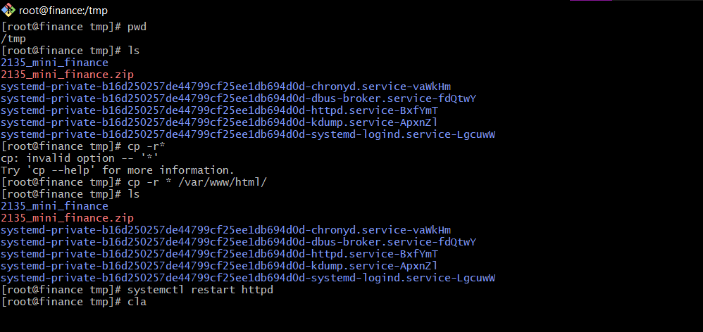

-check the httpd status and disable the firewall if enabled

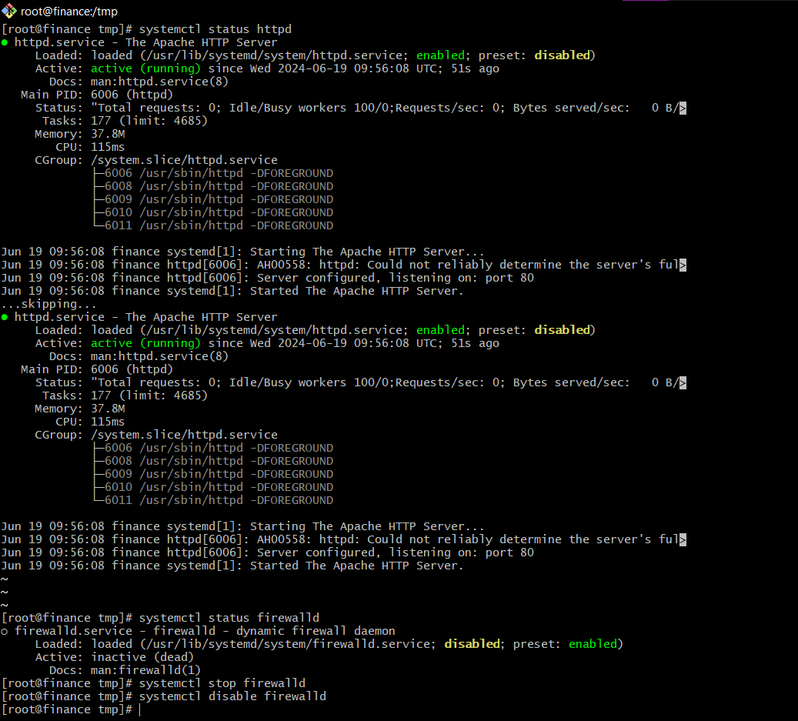

-now u can see your website template

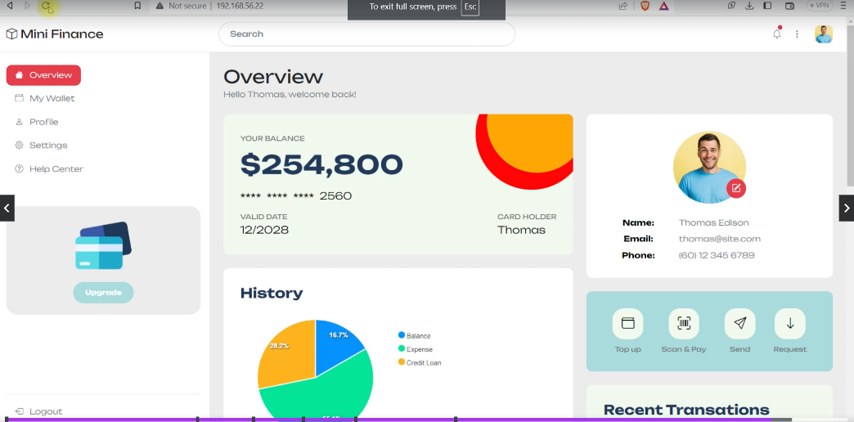

5.wordpress setup

-download ubuntu20

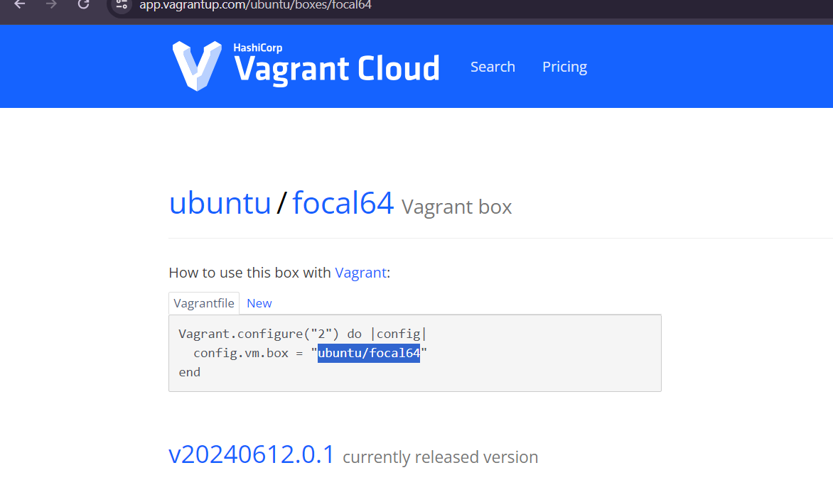

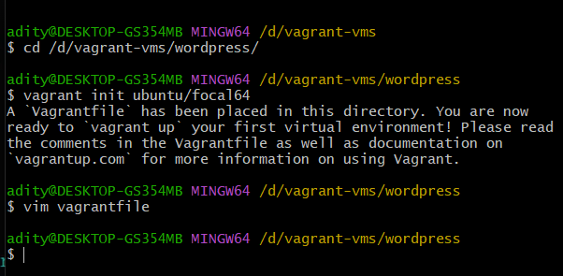

-uncomment and make the following changes in the .vagrantfile

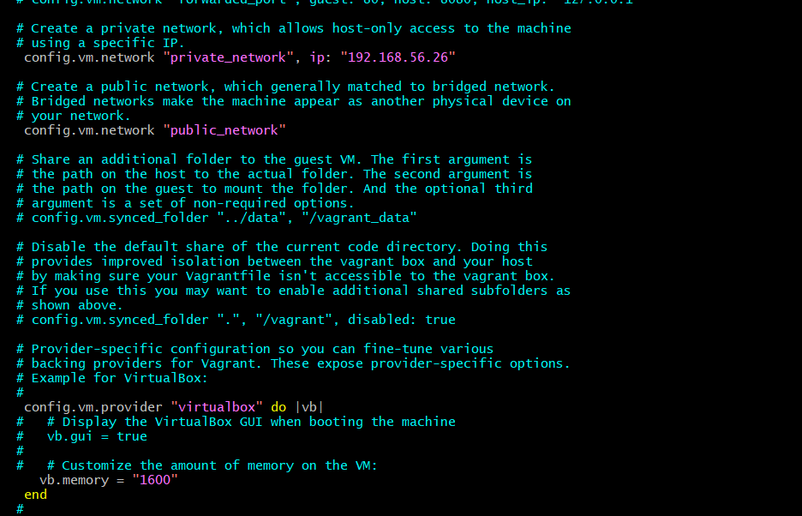

-change the hostname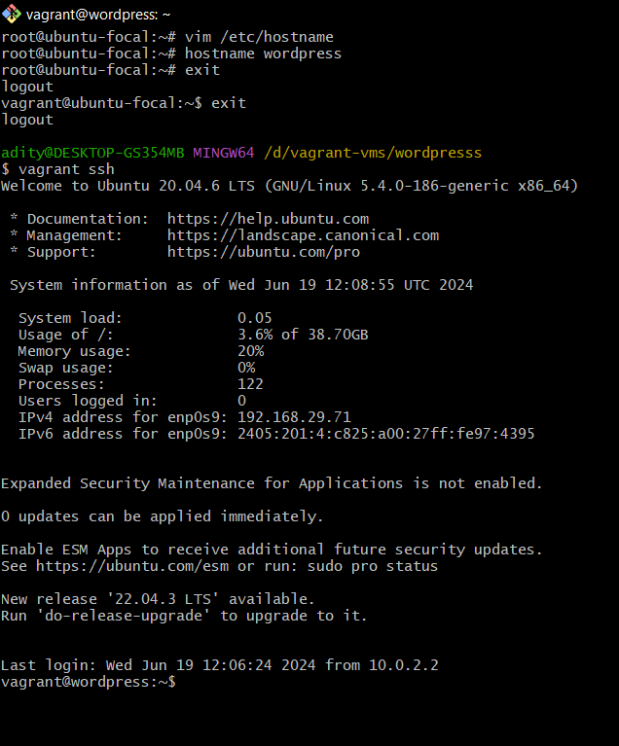

-execute this after making changes in the vagrant file

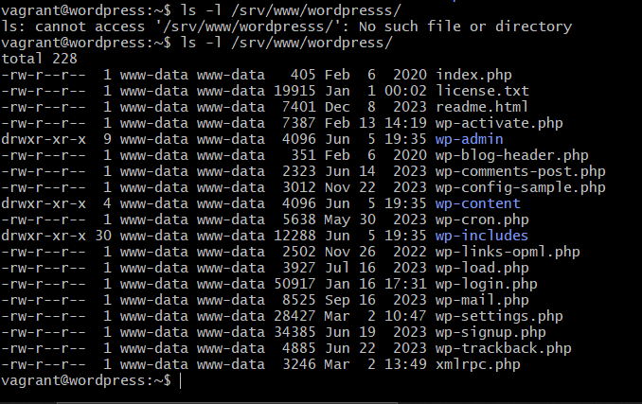

We need to configure this file dir

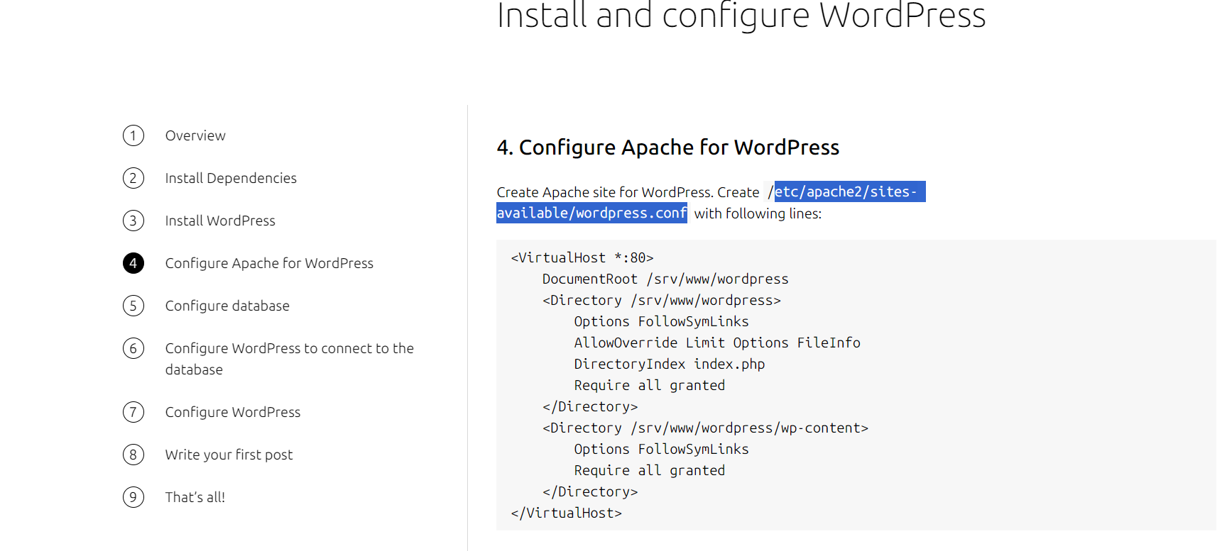

httpsubuntu.comtutorialsinstall-and-configure-wordpress

step2:

sudo apt update

sudo apt install apache2 \

ghostscript \

libapache2-mod-php \

mysql-server \

php \

php-bcmath \

php-curl \

php-imagick \

php-intl \

php-json \

php-mbstring \

php-mysql \

php-xml \

php-zip

step3:

sudo mkdir -p /srv/www:createa a new dir

sudo chown www-data: /srv/www:changing the ownership of that directory

curl https://wordpress.org/latest.tar.gz | sudo -u www-data tar zx -C /srv/www:

downloading this from the link extracting it and putting it to this dir

step4:

Create Apache site for WordPress. Create /etc/apache2/sites-available/wordpress.conf

add this into the file

<VirtualHost *:80>

DocumentRoot /srv/www/wordpress

<Directory /srv/www/wordpress>

Options FollowSymLinks

AllowOverride Limit Options FileInfo

DirectoryIndex index.php

Require all granted

</Directory>

<Directory /srv/www/wordpress/wp-content>

Options FollowSymLinks

Require all granted

</Directory>

</VirtualHost>

---Enable the site with:

sudo a2ensite wordpress

----Enable URL rewriting with:

sudo a2enmod rewrite

----Disable the default “It Works” site with:

sudo a2dissite 000-default

step5

$ sudo mysql -u root

mysql> CREATE DATABASE wordpress;

Query OK, 1 row affected (0,00 sec)

mysql> CREATE USER wordpress@localhost IDENTIFIED BY 'admin123';

Query OK, 1 row affected (0,00 sec)

mysql> GRANT SELECT,INSERT,UPDATE,DELETE,CREATE,DROP,ALTER

-> ON wordpress.*

-> TO wordpress@localhost;

Query OK, 1 row affected (0,00 sec)

mysql> FLUSH PRIVILEGES;

Query OK, 1 row affected (0,00 sec)

mysql> quit

Bye

step6:

sudo -u www-data cp /srv/www/wordpress/wp-config-sample.php /srv/www/wordpress/wp-config.php

sudo -u www-data sed -i 's/database_name_here/wordpress/' /srv/www/wordpress/wp-config.php

sudo -u www-data sed -i 's/username_here/wordpress/' /srv/www/wordpress/wp-config.php

sudo -u www-data sed -i 's/password_here/admin123/' /srv/www/wordpress/wp-config.php

sudo -u www-data vi /srv/www/wordpress/wp-config.php

find the entries stated in the website deletete and add these

define('AUTH_KEY', 'baxH%h;jAF 8sZ-0XP+Zdc*5|LFs h|dHfh8-Rkbg%iZ|<U1K6Gyft04S1J!u7qA');

define('SECURE_AUTH_KEY', 'W%gy=@4(G:9OJp|cYhPk)+2pIzT=paMY.x]=xj5b,K(QDu&]f.(%Gl?Gw9i+_V61');

define('LOGGED_IN_KEY', ')f_*E?GGS33=(*)mAi)RY.Hl^8yUZWn#$u|G: [>tW6.sA6A1lwSd7n9vu=~!!&]');

define('NONCE_KEY', 'Gigjt+9+;y6Ow||Ex,=_~0[;a~U%[ir)LNX/;=z_mzIX!]L|3%Ulc)o&k~ZS J~W');

define('AUTH_SALT', 'jot*i*6=Oow$Z mc)Ebp[+G1|*D@:Z&-?:*!EcJkt;oc 1/wTh1vJve<<j, ]i9{');

define('SECURE_AUTH_SALT', 'R2MVA)K-~q$~s;p~R$|y^3(LNY16C*]caMwX%^0Py<bxQT~EO&~<Vq|brdlB}Ds%');

define('LOGGED_IN_SALT', 'x|a4:$qr?^yRDS_;LN+@Q#RM3_IP|pS|V5Vf<`LZscAu-a)/SjqUQ[dh$`]r#%fI');

define('NONCE_SALT', 'PK2r-3<0o{L4bGBx(h}JJ?p)Ls+ZBMF$8GlN}8$M%xurH|ykIU~ +~:srrUC~_hW');

step7:find the ipaddress

ip addr show

---find rthe ipaddress and paste it on net

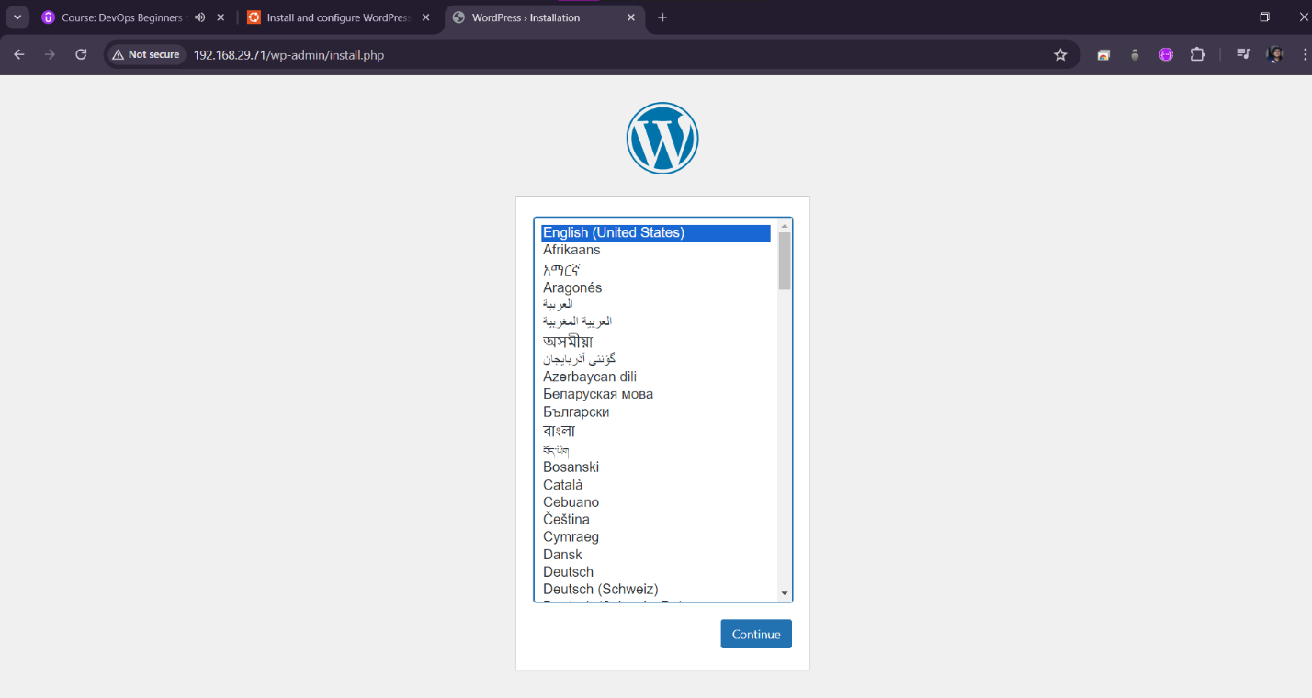

6.automate website setup

1.open vs-code and copt he finance file and rename it to financeIAC

-delete the .vagrantfolder

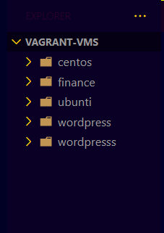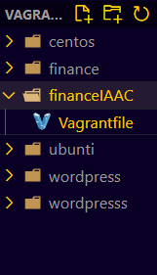

-add cmd thru provisioning in the vagrantfile

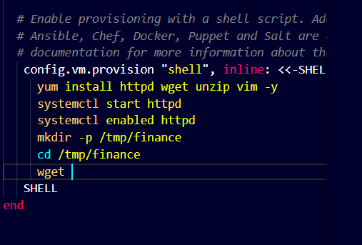

-copy the link

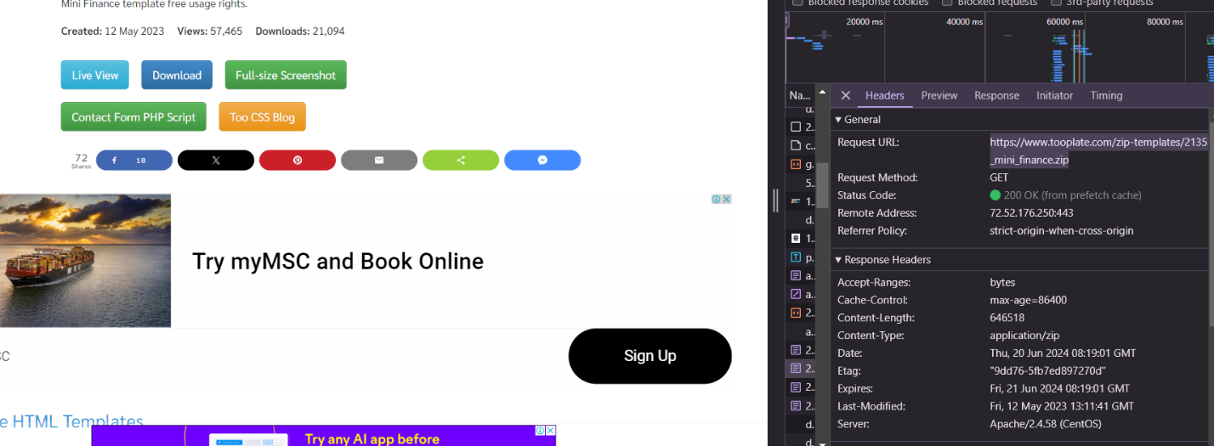

-add these

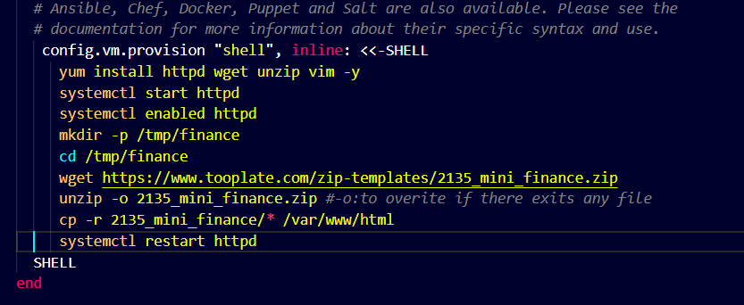

-vagrant up will run all the provisioning cmds

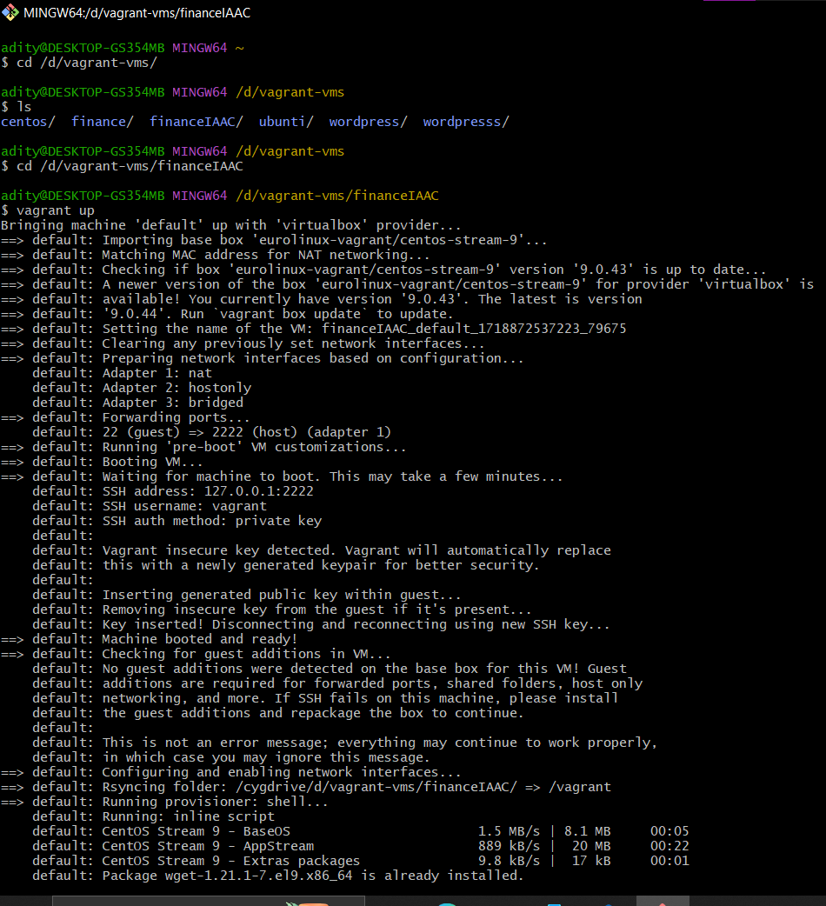

* Can see the website is created

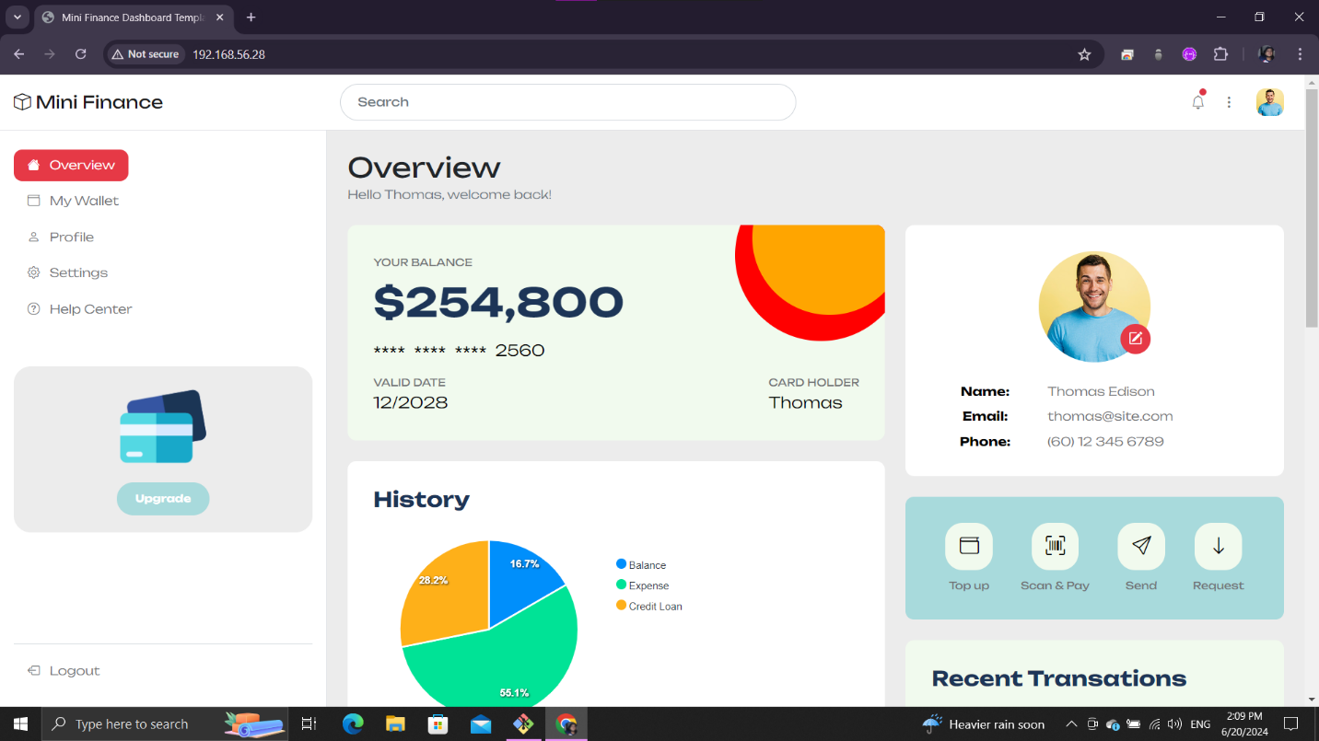

-destry the vagrant at the end

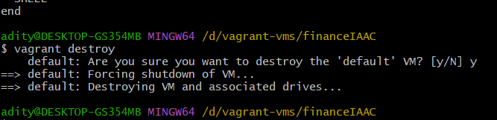

7.automate wordpress setup

-make same changes as above

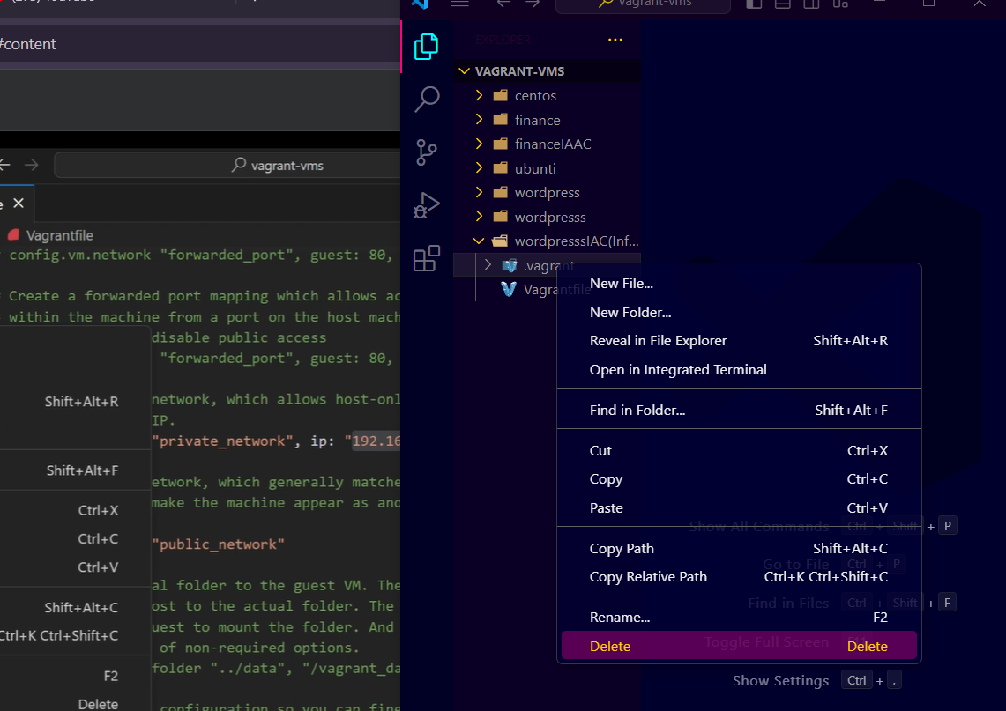

-make changes to the cmds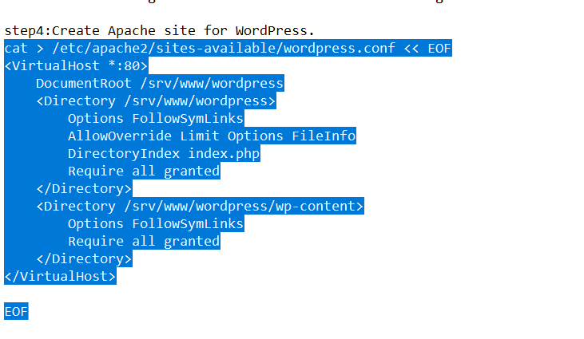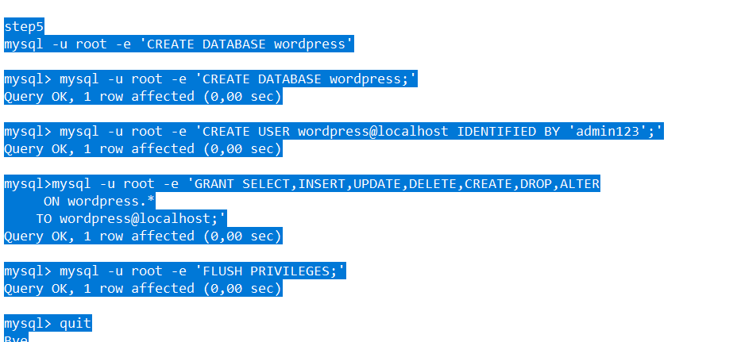

Paste and run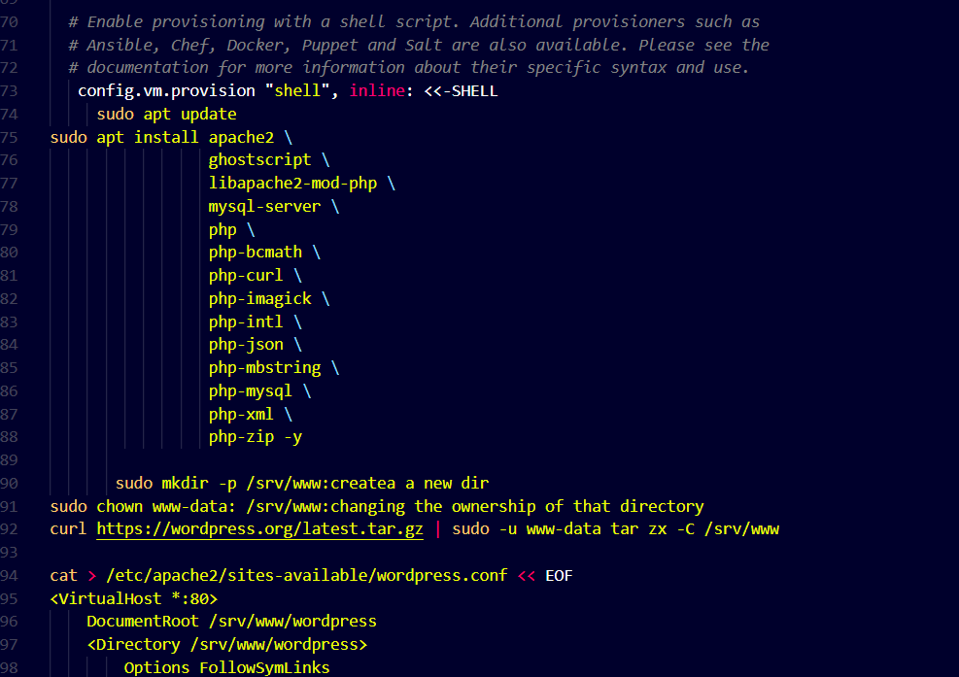

-vagrant up

Copy ipaddress

Paste on web and u r done

